
Touchstones Project
Netcards

Power Netcards with Text

Art HRJ
Blind HRJ
Child HRJ
Chimpanzee HRJ

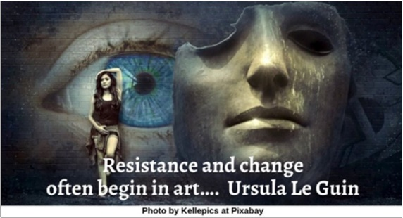

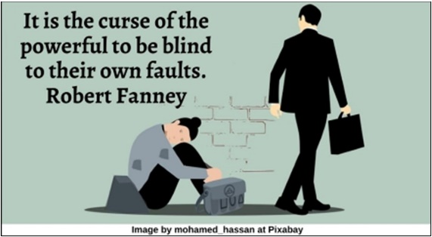

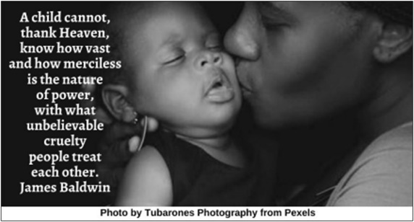

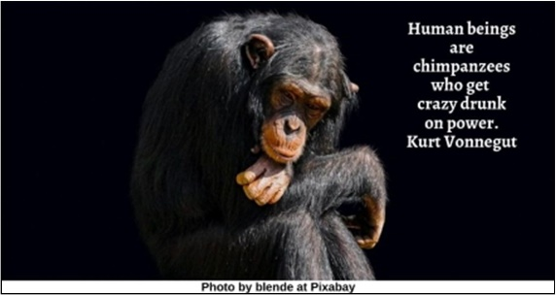

Clay HRJ
Corporations HRJ
Corruption HRJ
Destruction HRJ

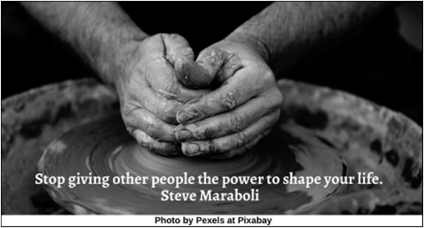

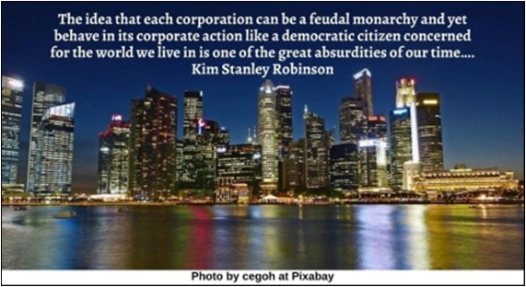

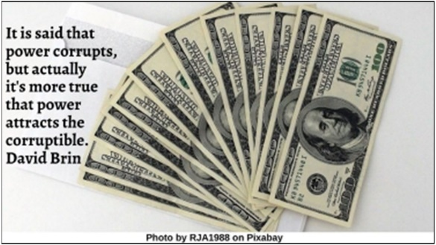

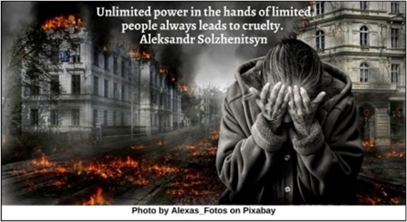

Fake News HRJ
Fire HRJ
Fist HRJ
Giving HRJ

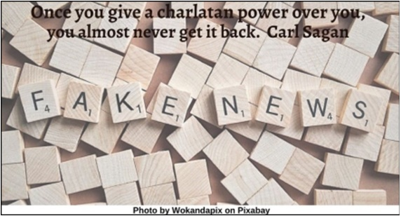

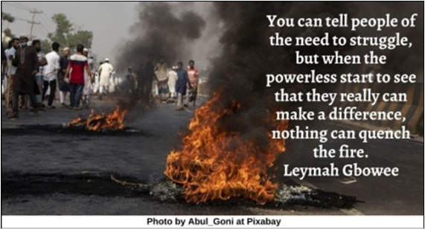

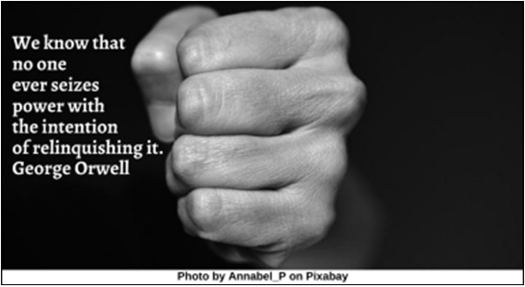

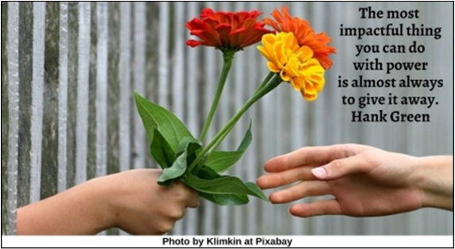

Hoarding Power HRJ
Injustice HRJ
Love HRJ
More Power HRJ

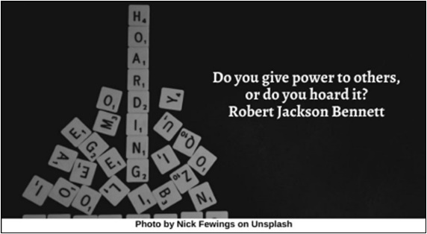

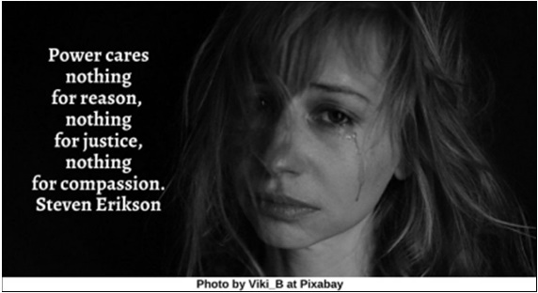

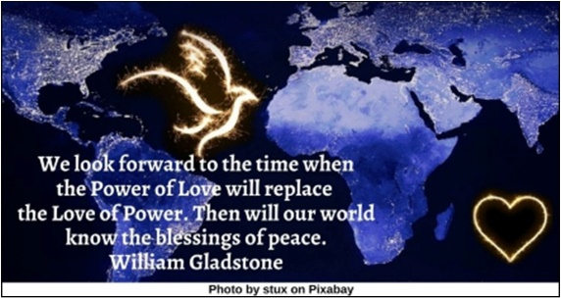

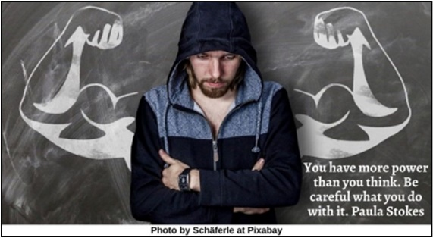

Police HRJ
Poverty HRJ
Power Can Corrupt HRJ
Power HRJ

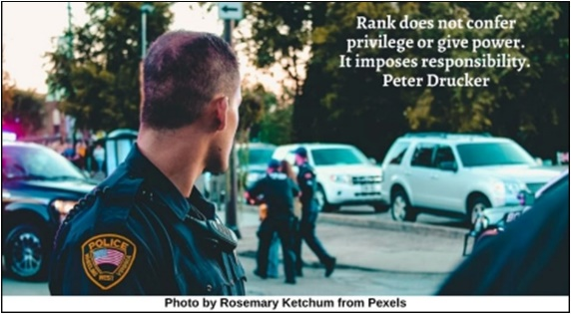

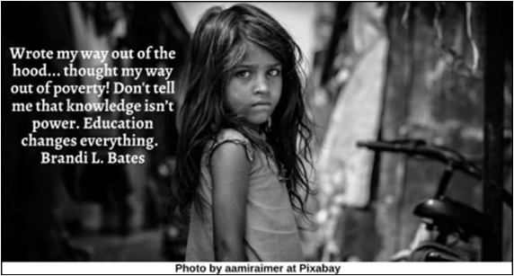

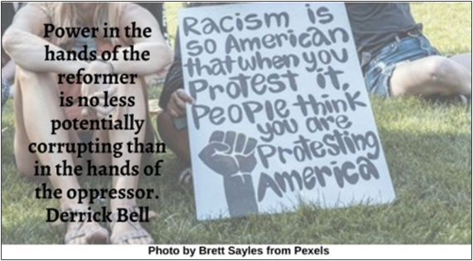

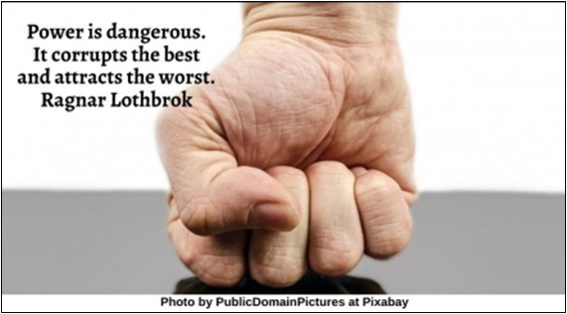

Power of Love HRJ
Protest HRJ
Resistance HRJ
Sacrifice HRJ

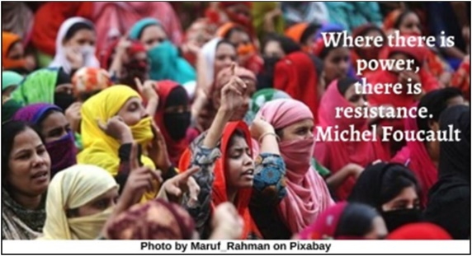

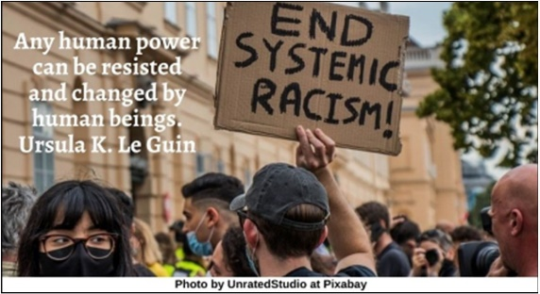

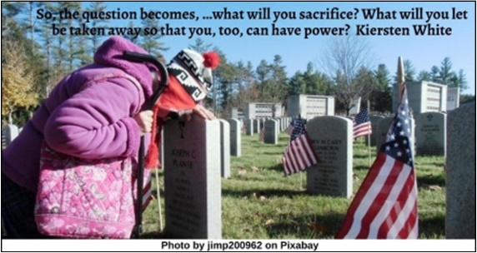

Samurai HRJ
Seeds HRJ
Speak No Evil HRJ
Thinker HRJ

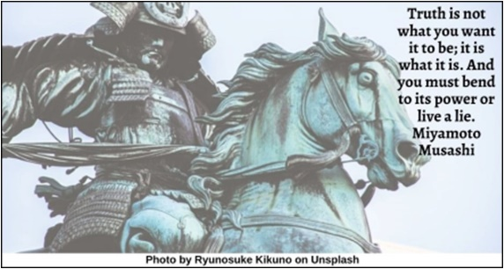

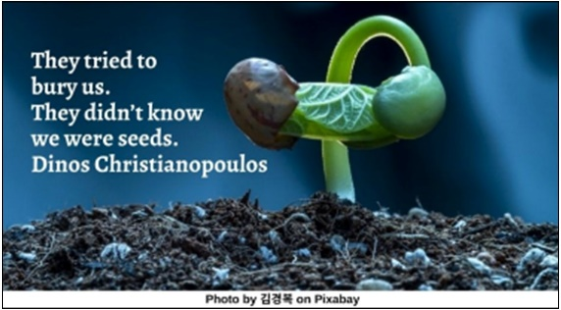

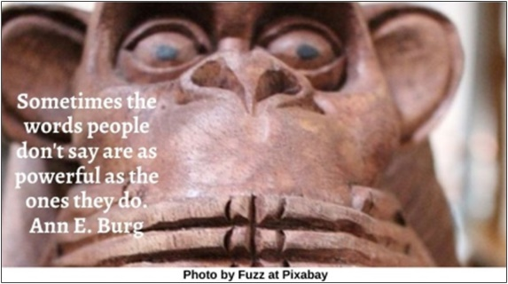

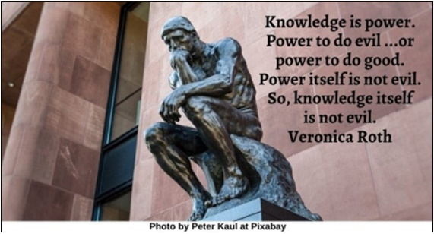

Tides HRJ
Wall Street HRJ
Washing Hands HRJ

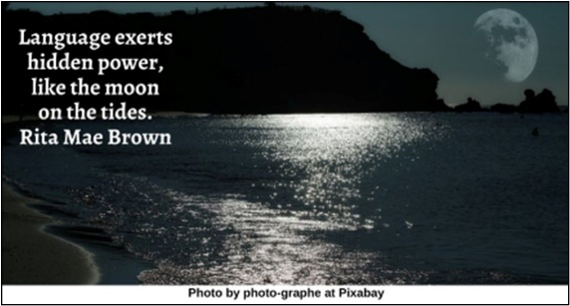

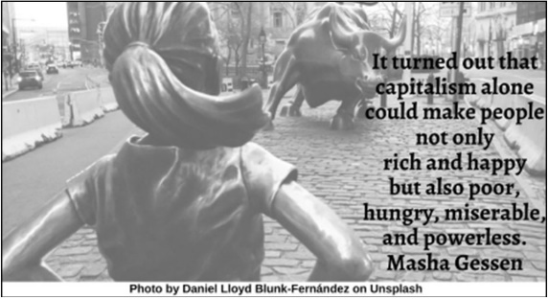

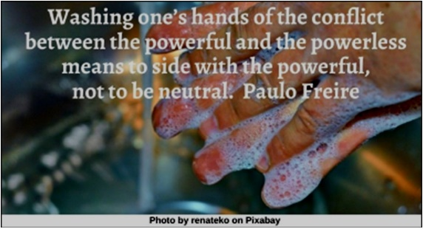

Text of Quotes
Art HRJ
Resistance and change often begin in art…. Ursula K. Le Guin

Blind HRJ
It is the curse of the powerful to be blind to their own faults. Robert Fanney

Child HRJ
A child cannot, thank Heaven, know how vast and how merciless is the nature of power, with what unbelievable cruelty people treat each other. James Baldwin

Chimpanzee HRJ
Human beings are chimpanzees who get crazy drunk on power. Kurt Vonnegut

Clay HRJ
Stop giving other people the power to shape your life. Steve Maraboli

Corporations HRJ
The idea that each corporation can be a feudal monarchy and yet behave in its corporate action like a democratic citizen concerned for the world we live in is one of the great absurdities of our time…. Kim Stanley Robinson

Corruption HRJ
It is said that power corrupts, but actually it's more true that power attracts the corruptible. David Brin

Destruction HRJ
Unlimited power in the hands of limited people always leads to cruelty. Aleksandr Solzhenitsyn

Fake News HRJ
Once you give a charlatan power over you, you almost never get it back. Carl Sagan

Fire HRJ
You can tell people of the need to struggle, but when the powerless start to see that they really can make a difference, nothing can quench the fire. Leymah Gbowee

Fist HRJ
We know that no one ever seizes power with the intention of relinquishing it. George Orwell

Giving HRJ
The most impactful thing you can do with power is almost always to give it away. Hank Green

Hoarding Power HRJ
Do you give power to others, or do you hoard it? Robert Jackson Bennett

Injustice HRJ
Power cares nothing for reason, nothing for justice, nothing for compassion. Steven Erikson

Love HRJ
Power is of two kinds. One is obtained by the fear of punishment and the other by acts of love. Mahatma Gandhi

More Power HRJ
You have more power than you think. Be careful what you do with it. Paula Stokes

Police HRJ
Rank does not confer privilege or give power. It imposes responsibility. Peter Drucker

Poverty HRJ
Wrote my way out of the hood... thought my way out of poverty! Don't tell me that knowledge isn’t power. Education changes everything. Brandi L. Bates

Power Can Corrupt HRJ
Power in the hands of the reformer is no less potentially corrupting than in the hands of the oppressor. Derrick Bell

Power HRJ
Power is dangerous. It corrupts the best and attracts the worst. Ragnar Lothbrok

Power of Love HRJ
We look forward to the time when the Power of Love will replace the Love of Power. Then will our world know the blessings of peace. William Gladstone

Protest HRJ
Where there is power, there is resistance. Michel Foucault

Resistance HRJ
Any human power can be resisted and changed by human beings. Ursula K. Le Guin

Sacrifice HRJ
So, the question becomes, …what will you sacrifice? What will you let be taken away so that you, too, can have power? Kiersten White

Samurai HRJ
Truth is not what you want it to be; it is what it is. And you must bend to its power or live a lie. Miyamoto Musashi

Seeds HRJ
They tried to bury us. They didn’t know we were seeds. Dinos Christianopoulos

Speak No Evil HRJ
Sometimes the words people don't say are as powerful as the ones they do. Ann E. Burg

Thinker HRJ
Knowledge is power. Power to do evil ...or power to do good. Power itself is not evil. So, knowledge itself is not evil. Veronica Roth

Tides HRJ
Language exerts hidden power, like the moon on the tides. Rita Mae Brown

Wall Street HRJ
It turned out that capitalism alone could make people not only rich and happy but also poor, hungry, miserable, and powerless. Masha Gessen

Washing Hands HRJ
Washing one’s hands of the conflict between the powerful and the powerless means to side with the powerful, not to be neutral. Paulo Freire

